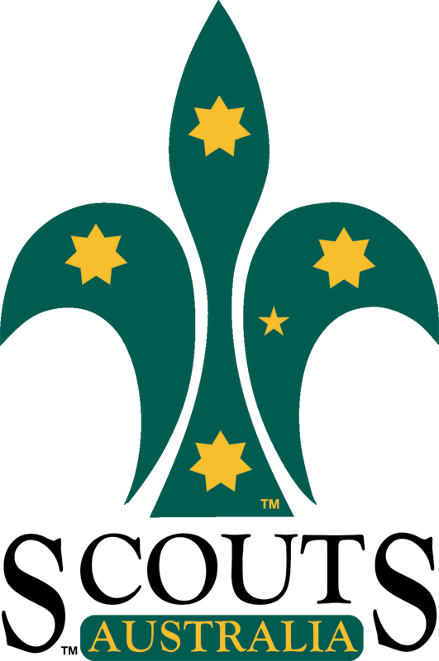
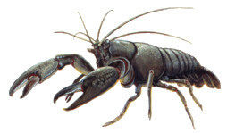
Rosanna Cubs

Yabby / BBQ Night

Next Tuesday (the 11th) we’ll be having a BBQ and Yabbying night at Binnak Park in Nth Watsonia.

Location: Binnak Park (Melway 10 D11, http://goo.gl/H4Haus ). Closest street is Binnak Dr, between Glendalough Ct and Dunraven Ct. On some Melways, the area we’re meeting is just marked as “Play”, but there is a BBQ area and small lakes there.
Time: Tuesday 11th February, 6:30pm start and pickup at 8:30pm.
Food: Meat, bread, drinks etc., will be supplied for the Cubs.
Parents/Siblings: Parents/siblings are welcome, but please bring your own food to cook/eat and parents please supervise your other children.
For Yabbying: Please bring an old stocking and coat hanger if you wish (to make a ‘net’ – some will be supplied) and, if you intend on being successful, a bucket (or ice-cream container and lid) to take your yabby(s) home. Yabby meat and string will be supplied.
Bring: Cubs to wear hat and uniform – wear sunscreen.

Catering: Please contact Wayne (Akela) at akela@rosannacubs.org or 0411 121 495 ASAP
re any special food requirements or other queries.

Regards

Akela (Wayne)
akela@rosannacubs.org
0411 121 495

See us at www.rosannacubs.org

